**ELE222E INTRODUCTION TO ELECTRONICS (10730)**

**Final Exam** 🖉 **4 January 2014** ⌛ **15.00-17.00**

**İnci ÇİLESİZ, PhD, 5201, 5202, 5204**

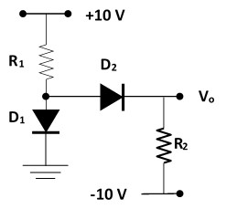

1. Assuming constant voltage drop in forward bias, i.e., **VD = 0,7 V**, calculate **Vo** and the current flowing through D1 (**ID1**) for

**R1 = 10k** and **R2 = 5k** , and (7,5 p)

**R1 = 5k** and **R2 = 10k** (7,5 p).

1. Study the OPAMP circuit below for **Vo_max = 10V**, **Vo_min =-10V**.
   1. 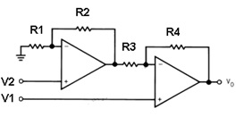Find **Vo** as a function of input voltages, i.e., **Vo = f (V1, V2).** (10 p)
   2. 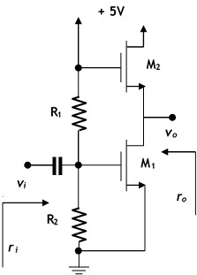Assuming **R1 = R4 = 100k** determine resistor values for **Vo = 2 (V1 - V2)**. (10 p)
   3. Calculate **f (10 V, 0 V)** and  
      **f (5 V, 10 V)**. (10 p)
2. The MOS transistors shown on the circuit to the left have the following properties: **VT = 1 V, λ = 0**.
   1. Calculate $β_{2} = \frac{1}{2}μC_{ox}{\left(\frac{W}{L}\right)}_{2}$ that would satisfy **ID2 = 1 mA** and **VDS2 = 2,5 V**. (10 p)
   2. Find the voltage gain $A_{v}= \frac{v_{o}}{v_{i}}$ and the output resistance **ro.** (10 p)
   3. Calculate $β_{1} = \frac{1}{2}μC_{ox}{\left(\frac{W}{L}\right)}_{1}$ and resistors **R1** & **R2** that would satisfy **ri = 47k** and $A_{v}= -3$**.** (10 p)
3. For the BJT amplifier circuit in the figure below **β = hFE = hfe =250, |VBE|=0,6V** and **VA = ∞**.
   1. 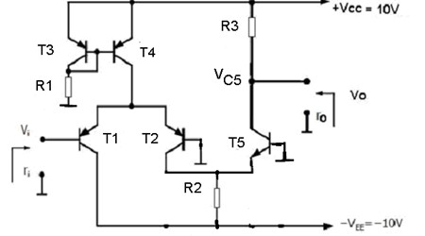Calculate **R1, R2 and IC4** for **Vi = 0V, VC5 = 5V, ri = 25k** and **ro = 10k**. (10 p)
   2. Find the voltage gain $A_{v}= \left|\frac{v_{o}}{v_{i}}\right|$ and **CMRR** assuming **VA_T4 = 100 V.** (10 p)
   3. Recall conditions for saturation and cut-off. Determine range of **Vo** for   
      **VCE_SAT_5 = 0,2 V**. (5 p)

**SOLUTIONS:**

1. Pure mathematics assuming the directions given below yield the following results for currents through resistors and diodes:

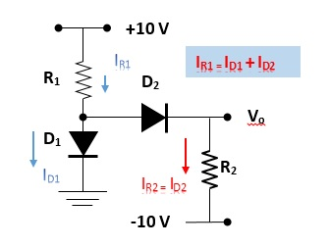

|  |  |  |  |  |  |  |  |  |  |
| --- | --- | --- | --- | --- | --- | --- | --- | --- | --- |
|  | **R1** | **R2** |  |  |  |  |  |  |  |
| **a** | 1,00E+04 | 5,00E+03 | **IR1** | 9,30E-04 | **ID2** | 2,00E-03 | **ID1** | **-1,07E-03** | NO WAY |
| **b** | 5,00E+03 | 1,00E+04 | **IR1** | 1,86E-03 | **ID2** | 1,00E-03 | **ID1** | 8,60E-04 |  |

**INTERPRETATION**:

* 1. That means, when R1 = 10k and R2 = 5k, D2 is **NOT** conducting! THUS,
  2. When R1 = 5k and R2 = 10k ,

1. Recalling ideal OPAMP properties we immediately see that the current through R1 and R2 (let’s call it I1) and the current through R3 and R4 (let’s call it I2) are equal, however these two currents are NOT equal! Both OPAMPs are a non-inverting amplifiers.

$V_{o1}=\left(1+\frac{R_{2}}{R_{1}}\right)V_{2}$ and $I_{2}=\frac{V_{o1}-V_{1}}{R_{3}}$. Since $V_{o}=V_{1}-R_{4}I_{2}= V_{1}-R_{4}\frac{V_{o1}-V_{1}}{R_{3}} = V_{1}-R_{4}\frac{\left(1+\frac{R_{2}}{R_{1}}\right)V_{2}-V_{1}}{R_{3}}$, simplified

If **R1 = R4 = 100k**

To satisfy **Vo = 2 (V1 - V2)**, and

Using **R1 = R2 = R3 = R4 = 100k** sounds mathematically fine, but for **Vo_max = 10V**, **Vo_min =-10V** this is physically IMPOSSIBLE… $⇒f\left(10 V, 0V\right)=10 V$

Thinking slightly differently, if $V_{2}=0V⇒ V_{o1}=0V$ and the second OPAMP acts like a non-inverting amplifier with $V_{o}=V_{1}\left(1+\frac{R_{4}}{R_{3}}\right)=2V_{1}=20 V$ again physically IMPOSSIBLE…

Using **R1 = R2 = R3 = R4 = 100k** , this is also mathematically possible. However, thinking slightly differently, if $V_{2}=10V⇒ V_{o1}=20V$ and again this is physically IMPOSSIBLE… Thus $V_{o1}=10V⇒V_{o}=V_{1}-R_{4}I_{3}=V_{1}-R_{4}\frac{V_{o1}-V_{1}}{R_{3}}=5V-\left(10V-5V\right)=0 V$

1. Realizing
   1. that M2 is automatically in saturation by the wiring of the circuit since $V_{DS2}=V_{GS2} ⟹ {\left(\frac{1}{2}μ_{n}C_{ox}\frac{W}{L}\right)}_{2}=\frac{I_{D2}}{{\left(V_{GS}-V_{Tn}\right)}^{2}}=\frac{1mA}{{\left(2,5V-1V\right)}^{2}}=0,44 mA/V^{2}$
   2. that the same M2 only appears as a resistance $1/g_{m2}$ at AC, the MOS amplifier is a common source amplifier with $A_{v}=\frac{v_{o}}{v_{i}}=\frac{-R_{d}}{\frac{1}{g_{m1}}+R_{s}}=-\frac{\frac{1}{g_{m2}}}{\frac{1}{g_{m1}}}=-\frac{g_{m1}}{g_{m2}}$. That also means $r_{o}=1/g_{m2}$
   3. Also realize the drain currents of both MOS are equal.

$g_{m2}=\sqrt{{\left(2μ_{n}C_{ox}\frac{W}{L}\right)}_{2}I_{D2}}=0,943 S$, since $A_{v}=-\frac{g_{m1}}{g_{m2}}=-3⇒g_{m1}=3*g_{m2}=2,82 S$

$$⇒r_{o}=\frac{1}{g_{m2}}=1k06$$

$g_{m1}=\sqrt{{\left(2μ_{n}C_{ox}\frac{W}{L}\right)}_{1}I_{D2}}=2,82 S⇒{\left(2μ_{n}C_{ox}\frac{W}{L}\right)}_{1}=\frac{{g_{m1}}^{2}}{I_{D2}}=8 mA/V^{2}$

Now we need to find the VGS1.

,

Since input R of MOS is infinite $r_{i}=R_{1}∥R_{2}∥∞=R_{1}∥R_{2}=47k$

$$V_{GS1}=1,35 V=\frac{R_{2}}{R_{1}+R_{2}}5V ⇔\frac{R_{1}R_{2}}{R_{1}+R_{2}}=47k=R_{1}*\frac{R_{2}}{R_{1}+R_{2}}=R_{1}*\frac{1,35}{5}$$

$$⇒R_{1}=174k ⇒ R_{2}=64k4$$

1. Let’s start with **ri = 25k** and **ro = 10k**. $r_{o} =R_{C5} = R_{3} = 10k.$

$$V_{R3} = V_{CC}- V_{C5} = 5V ⇒R_{3}=\frac{V_{R3}}{I_{C5}}⇒I_{C5}=\frac{V_{R3}}{R_{3}}=\frac{5V}{10k}=0,5 mA⇒r_{e5}=\frac{V_{T}}{I_{C5}}=\frac{25 mV}{0,5 mA}=50Ω$$

$$r_{i}=2h_{fe}r_{e1.2}=2h_{fe}\frac{V_{T}}{I_{C1.2}}=25k ⇒ I_{C1.2}=\frac{2h_{fe}V_{T}}{25k}=0,5 mA⇒r_{e1.2}=\frac{V_{T}}{I_{C1.2}}=\frac{25 mV}{0,5 mA}=50Ω$$

$$I_{C4}=2I_{E1}=2{\frac{h_{fe}+1}{h_{fe}}I}_{C1}≅1 mA ⇒R_{1}=\frac{V_{CC}-V_{EB3}}{I_{C4}}=\frac{10V-0,6V}{1mA}=9k4$$

To find the remaining resistor R2 we need to write a loop equation that has R2 and T5 in it:

where

If T5 is in saturation then

If T5 is in cut-off then $I_{C5}=0 mA ⇒V_{o_max}=V_{CC}=10 V$